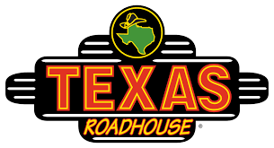

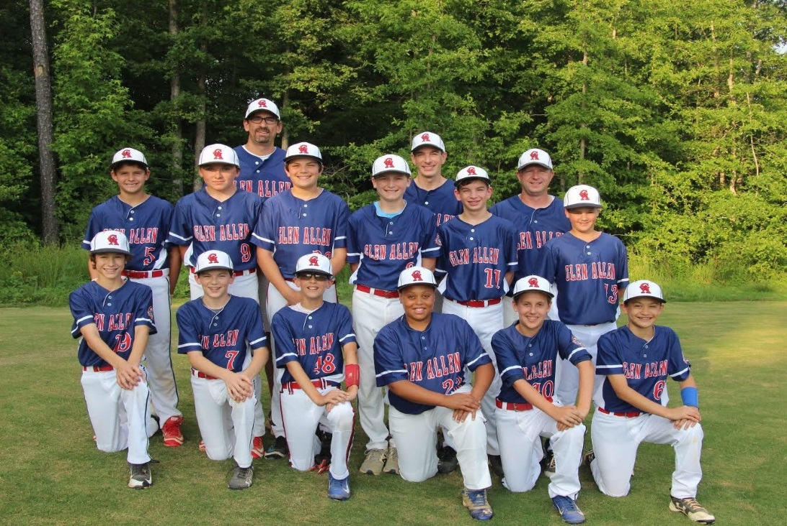
This talented group of boys have worked extremely hard to earn a spot at the Cal Ripken League World Series representing Glen Allen and the state of Virginia! They are 1 of 10 teams from across the country awarded this opportunity.
Texas Roadhouse will help support the Glen Allen 12U Major 60 baseball team by graciously donating 10% of their sales on the evening of Tuesday July 25th.
Please print this flyer and present to the wait staff with your bill. Your support is important and greatly appreciated!
GO GLEN ALLEN BASEBALL!!!
